Street Smart NJ Sample Social Media Posts

Pedestrian

Winter/Fall Images
Image | Post Text
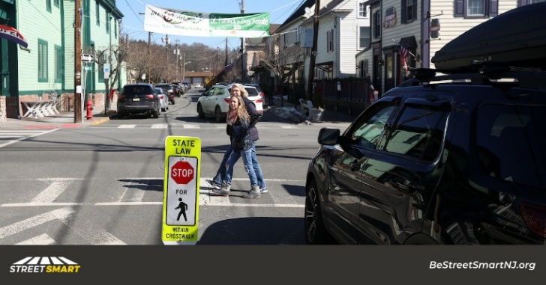 | Make eye contact with drivers when crossing busy streets and continue to watch for traffic as you cross.
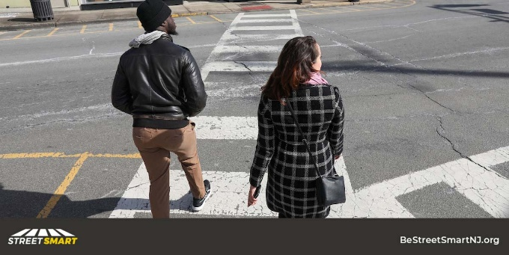 | Pedestrian safety tip: Before crossing look left, right, then left again.
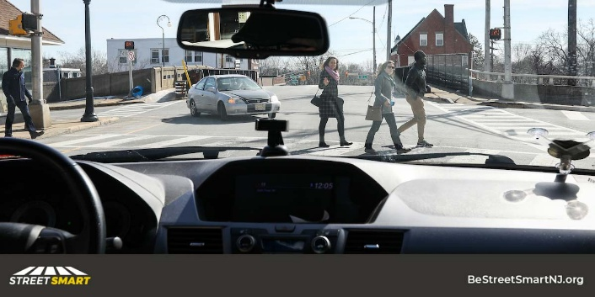 | Pedestrian safety tip: Watch out for drivers turning right on red when crossing the street.
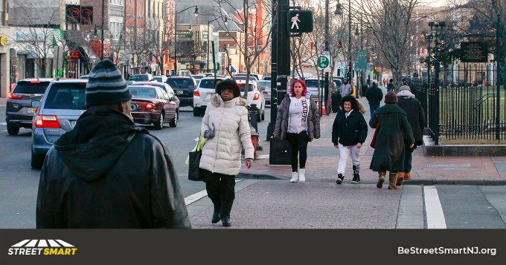 | Pedestrian Safety Tip: Cross at intersections or in crosswalks whenever possible. Wait for the green light or walk sign at signalized intersections before stepping into the road.
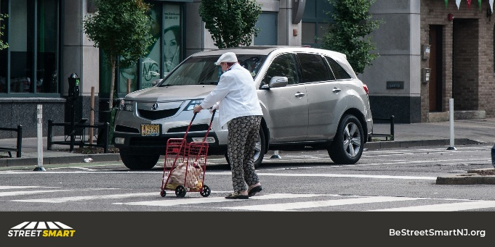 | Pedestrian Safety Tip: Using marked crosswalks and crossing at intersections increases your visibility, making it easier for drivers to see you. By law, drivers must stop for people in crosswalks.
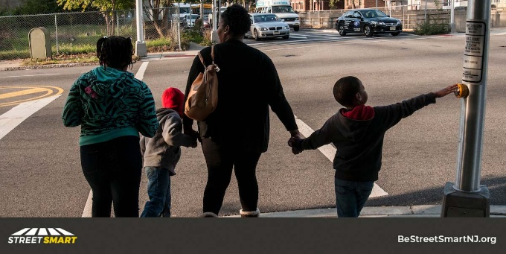 | Always hold your child’s hand and teach them to look left, right and then left again before crossing. Teaching safe behavior at a young age can save a life.
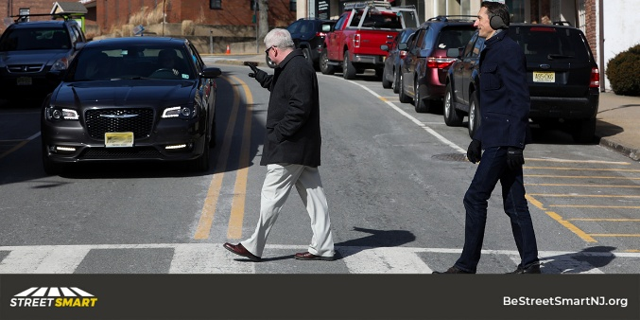 | Pedestrian safety tip: Cross the street at crosswalks, corners, or intersections when all cars have stopped. Anywhere else, cars have the right-of-way.
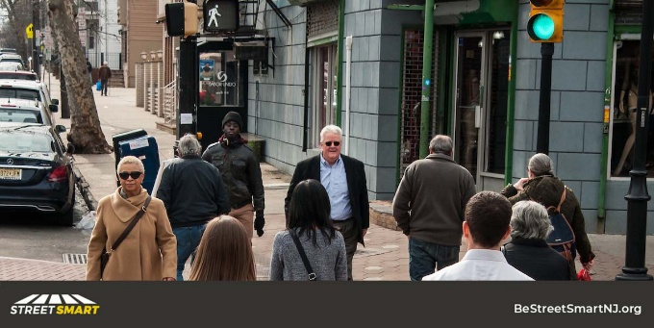 | Pedestrians must obey traffic signals & use crosswalks at signalized intersections. Failure to observe the law carries a $54 fine.
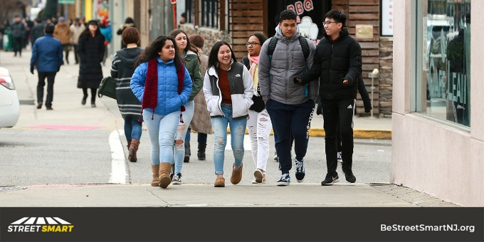 | Pedestrian safety tip: Use sidewalks or walk facing traffic where there are no sidewalks.
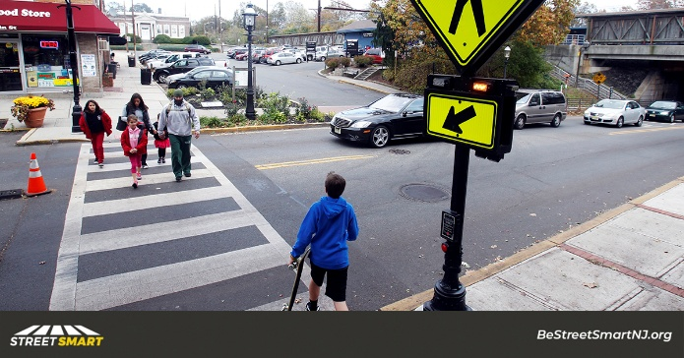 | Pedestrian safety tip: Always cross at corners and intersections. Use marked crosswalks where available.
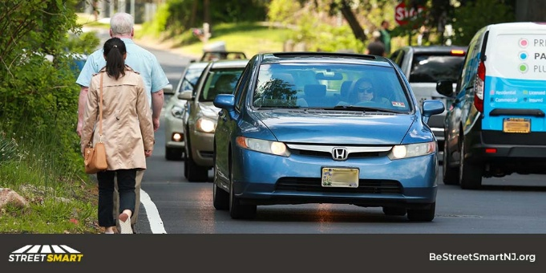 | Pedestrian Safety Tip: When there aren’t sidewalks, walk in the opposite direction of traffic so that you can see the vehicles approaching
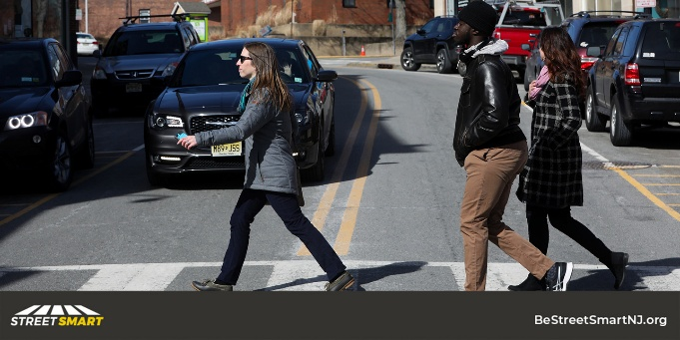 | Pedestrian Safety Tip: Avoid distractions when crossing. #HeadsUpPhonesDown

Spring/Summer Images
Image | Post Text
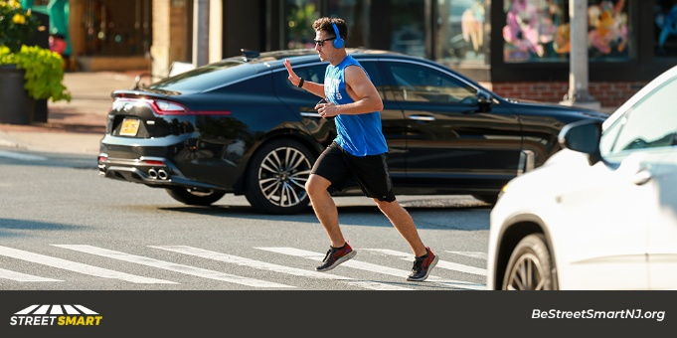 | Make eye contact with drivers when crossing busy streets and continue to watch for traffic as you cross.
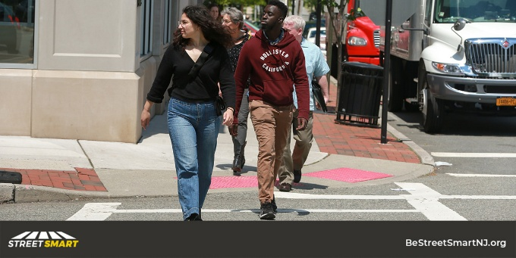 | Pedestrian safety tip: Before crossing look left, right, then left again.
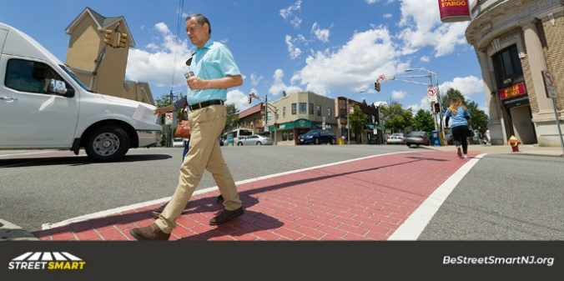 | Pedestrian safety tip: Watch out for drivers turning right on red when crossing the street.
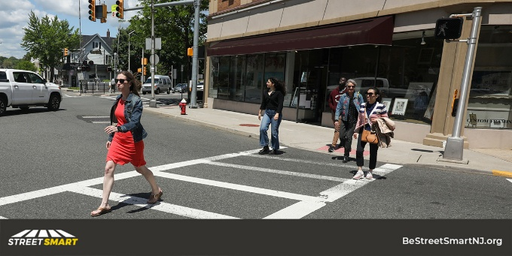 | Pedestrian Safety Tip: Cross at intersections or in crosswalks whenever possible. Wait for the green light or walk sign at signalized intersections before stepping into the road.
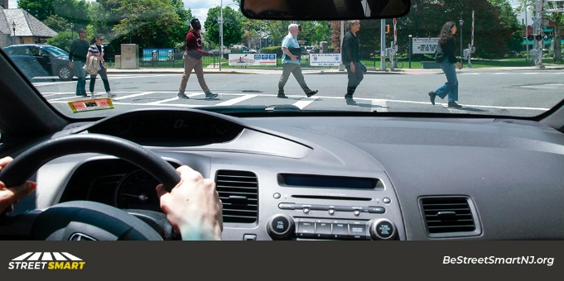 | Pedestrian Safety Tip: Using marked crosswalks and crossing at intersections increases your visibility, making it easier for drivers to see you. By law, drivers must stop for people in crosswalks.
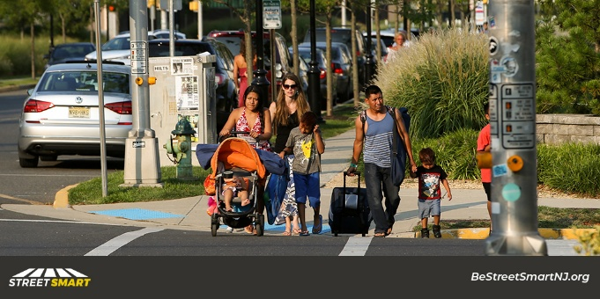 | Always hold your child’s hand and teach them to look left, right and then left again before crossing. Teaching safe behavior at a young age can save a life.
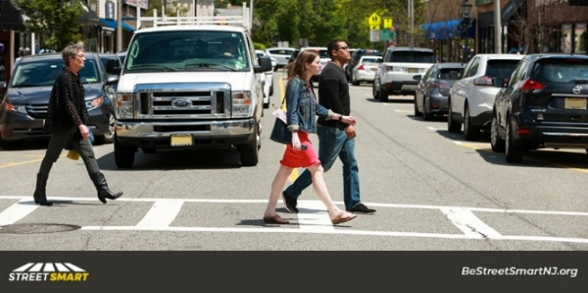 | Pedestrian safety tip: Cross the street at crosswalks, corners, or intersections when all cars have stopped. Anywhere else, cars have the right of way.
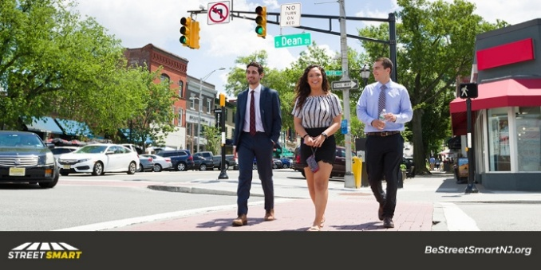 | Pedestrians must obey traffic signals & use crosswalks at signalized intersections. Failure to observe the law carries a $54 fine.
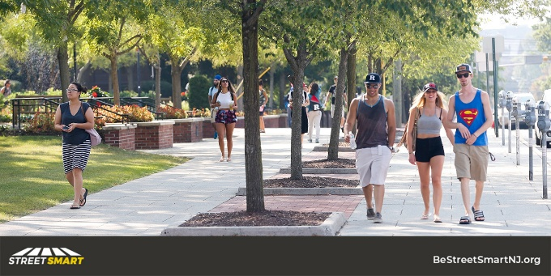 | Pedestrian safety tip: Use sidewalks or walk facing traffic where there are no sidewalks.
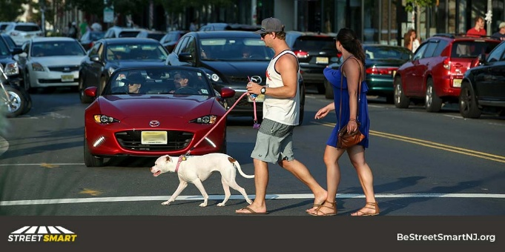 | Pedestrian safety tip: Always cross at corners and intersections. Use marked crosswalks where available.
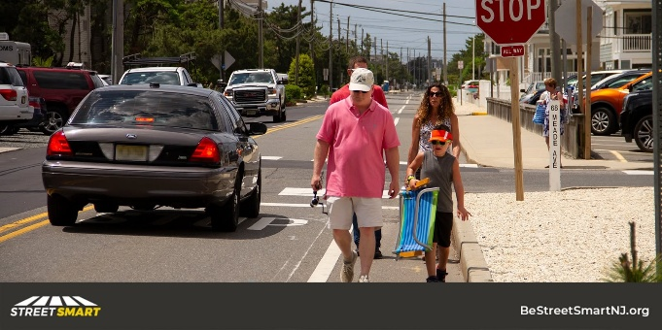 | Pedestrian Safety Tip: When there aren’t sidewalks, walk in the opposite direction of traffic so that you can see the vehicles approaching
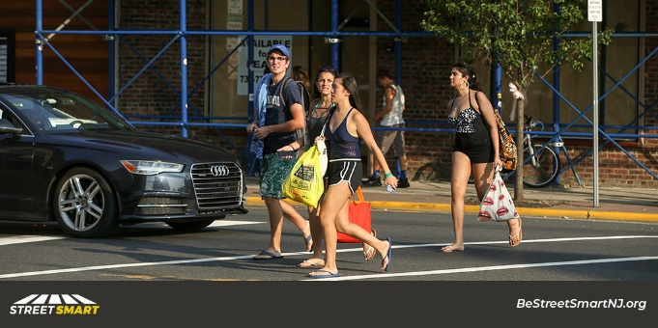 | Pedestrian Safety Tip: Avoid distractions when crossing. #HeadsUpPhonesDown

