Street Smart NJ Sample Social Media Posts

Driver Messages

Safe Passing Law
Additional resources at https://njbwc.org/safepass4nj/social-media-materials/
Image | Post Text
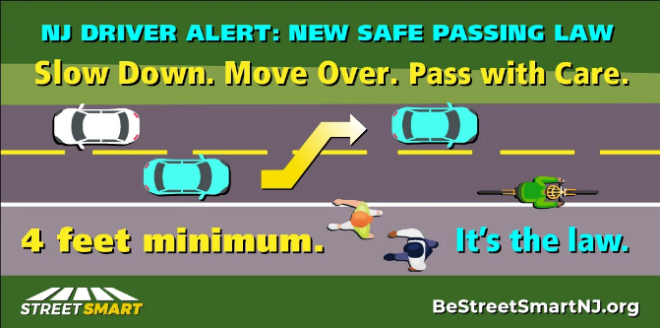 | New Jersey’s #SafePassingLaw requires motorists to move over 4 feet when safe, or slow down to 25 mph for pedestrians, bicyclists, wheelchair users and other vulnerable road users. #PassMeLikeYouKnowMe #BeStreetSmartNJ
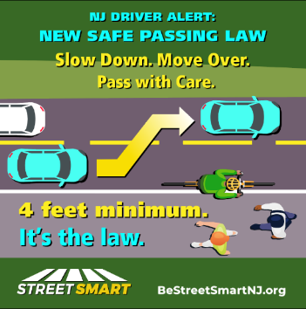 | Move over at least 4 feet (a full lane if available) when passing vulnerable road users – like people walking & biking. If that’s not possible, slow down and be prepared to stop. It's the law in NJ! #SafePass4NJ #PassMeLikeYouKnowMe #BeStreetSmartNJ
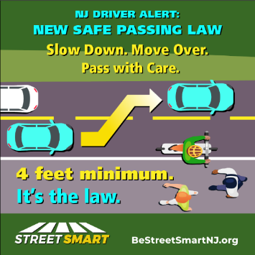 | Move over at least 4 feet (a full lane if available) when passing vulnerable road users – like people walking & scooting. If that’s not possible, slow down and be prepared to stop. It's the law in NJ! #SafePass4NJ #PassMeLikeYouKnowMe #BeStreetSmartNJ
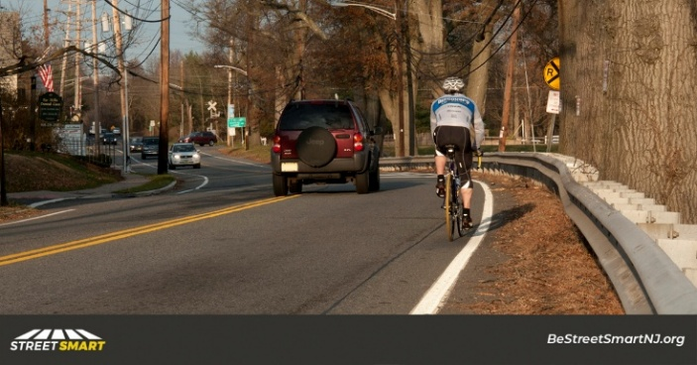 | Did you hear about NJ’s safe passing law? You must provide at least 4 feet, move over a lane, or slow down to 25 mph when passing a cyclist. Learn more: https://bestreetsmartnj.org/safe-passing #SafeDriversSaveLives
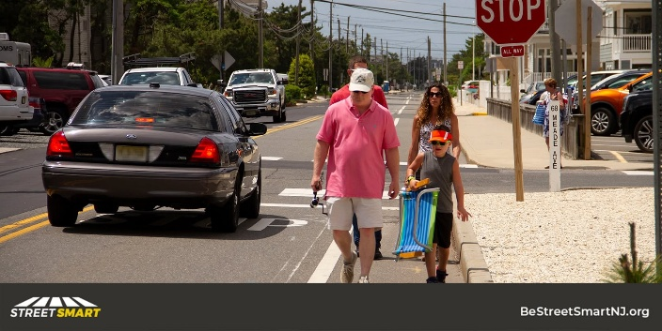 | DYK that NJ has a safe passing law? Drivers must move over if possible, provide at least 4 feet or slow down when passing people walking or biking. #SafePass4NJ #SafeDriversSaveLives #MoveOver #BeStreetSmartNJ
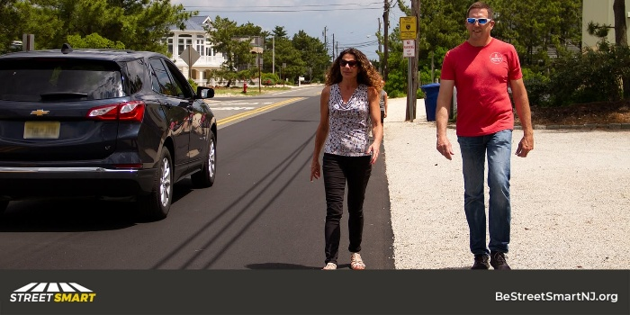 | Move over at least 4 feet (a full lane if available) when passing vulnerable road users – like people walking. If that’s not possible, slow down and be prepared to stop. #SafePass4NJ #SafeDriversSaveLives #MoveOver #BeStreetSmartNJ

Winter/Fall Images
Image | Post Text
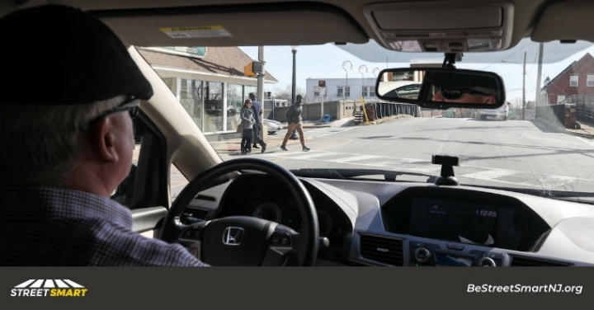 | Driver safety tip: Eliminate all distractions when driving. Your hands should be on the wheel and your focus should be on the road. #JustDrive #EndDD #HeadsUpPhonesDown #BeStreetSmartNJ
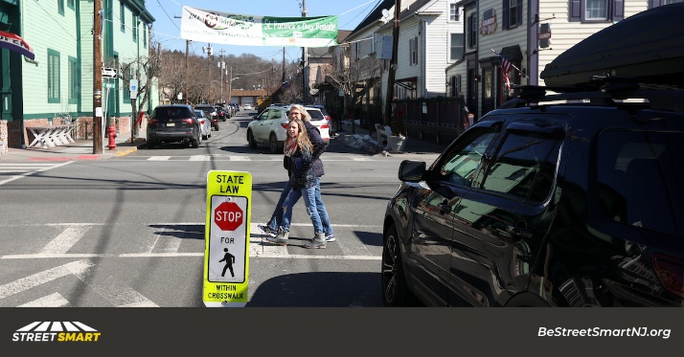 | Motorists in New Jersey MUST stop for people in marked crosswalks. Failure to do so could result in 2 points and a $200 fine. #BeStreetSmartNJ
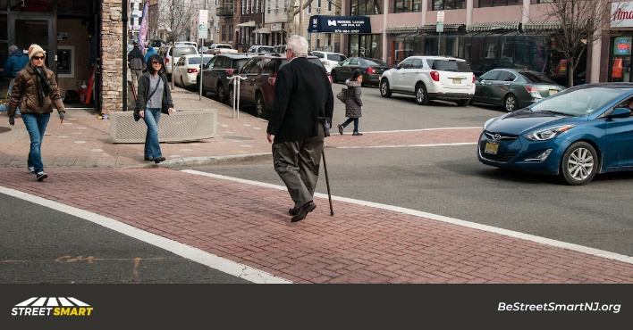 | Driver safety tip: Stop for people in marked crosswalks and yield when turning at intersections. It’s the law. #BeStreetSmartNJ
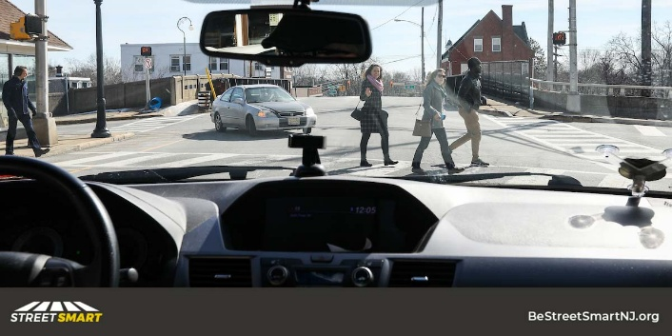 | Driver safety tip: When the light is red, a person crossing on a walk signal has the right of way. Stop and wait before turning, it’s the law. #BeStreetSmartNJ
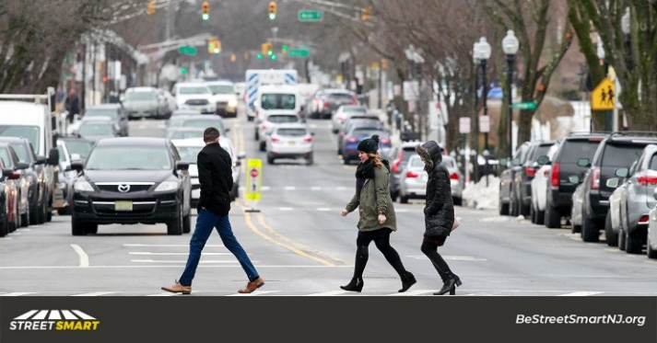 | Driver safety tip: Slow down for safety. Travelling at a lower speed WILL save a life. #BeStreetSmartNJ
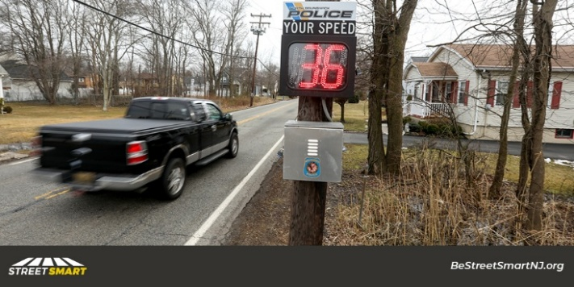 | More than half of pedestrian fatalities occur on local and county roads. Slow down for safety. #BeStreetSmartNJ
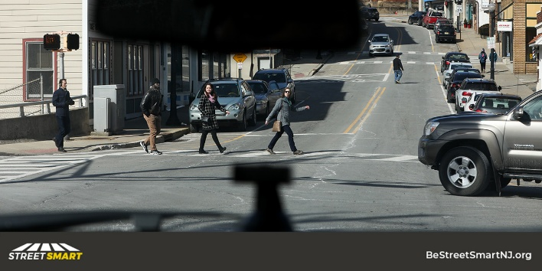 | Speeding, illegal turns and distracted driving put pedestrians at risk. We all have a responsibility to make our streets safer. #BeStreetSmartNJ
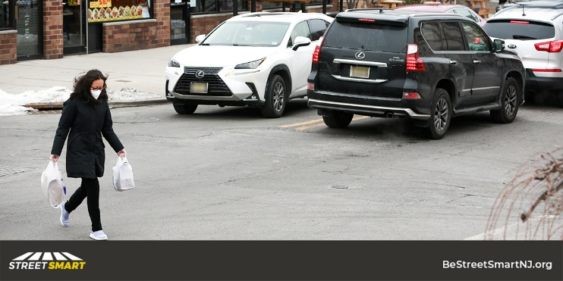 | All intersections are crosswalks. If the light is red, drivers MUST stop for pedestrians, even if the crosswalk is unmarked. Drive Smart. #BeStreetSmartNJ
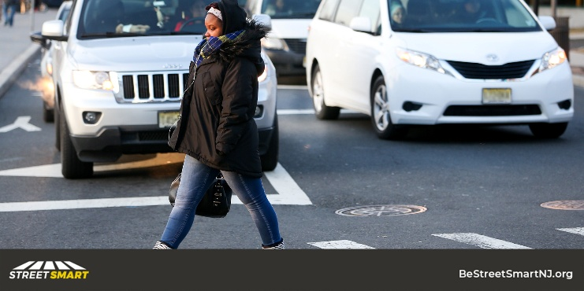 | Driver safety tip: Look and stop for pedestrians and bicyclists when turning right on red. #BeStreetSmartNJ
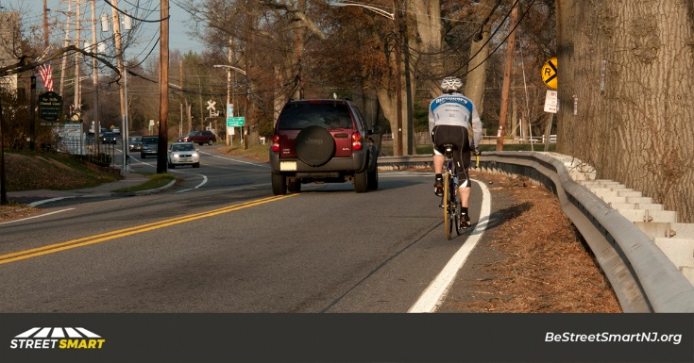 | Driver safety tip: Create a safety zone. Allow four feet when passing bicyclists or other vulnerable road users. #SafePass4NJ #PassMeLikeYouKnowMe #BeStreetSmartNJ
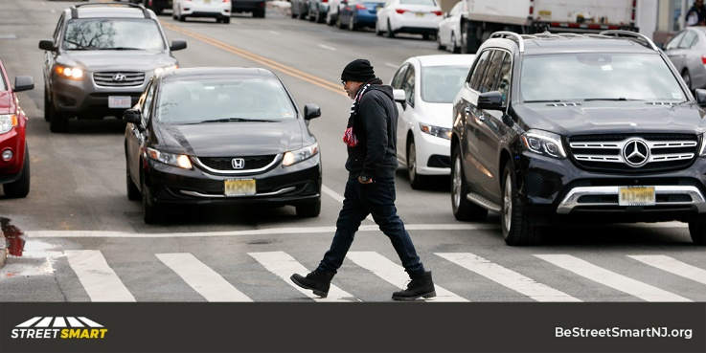 | Driver safety tip: Do not pass vehicles stopped at or adjacent to crosswalks and intersections. Look for pedestrians before proceeding. #BeStreetSmartNJ
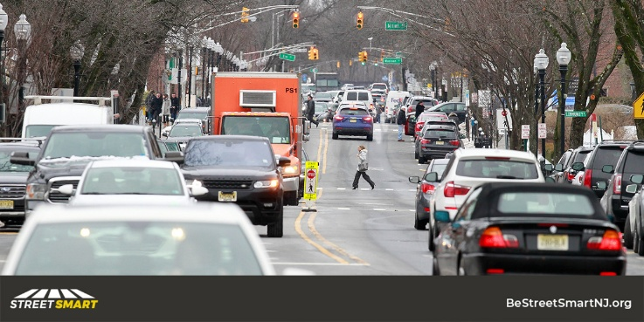 | Driver safety tip: Do not block or park in crosswalks. They’re pedestrian safety zones. #BeStreetSmartNJ
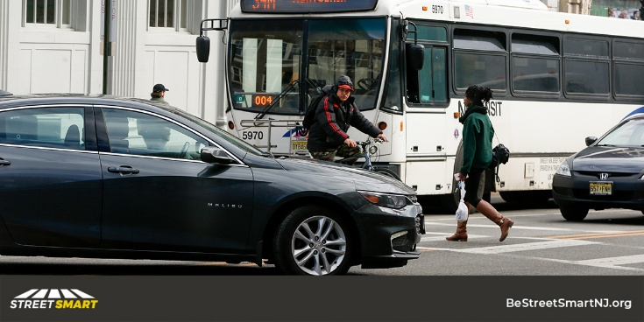 | Driver safety tip: Be extra alert around buses and look out for pedestrians. #BeStreetSmartNJ
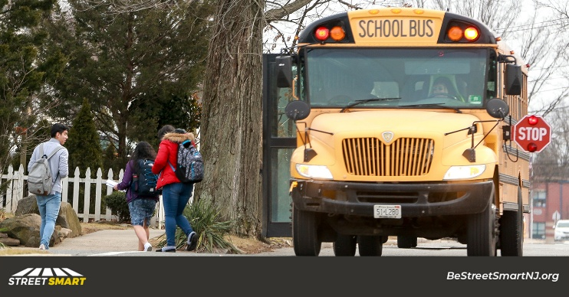 | Slow down for safety — especially around schools. If a person is struck by a car going 20 mph or slower, the odds of survival are good. Above 35 mph, the impact is likely to be fatal. #BeStreetSmartNJ
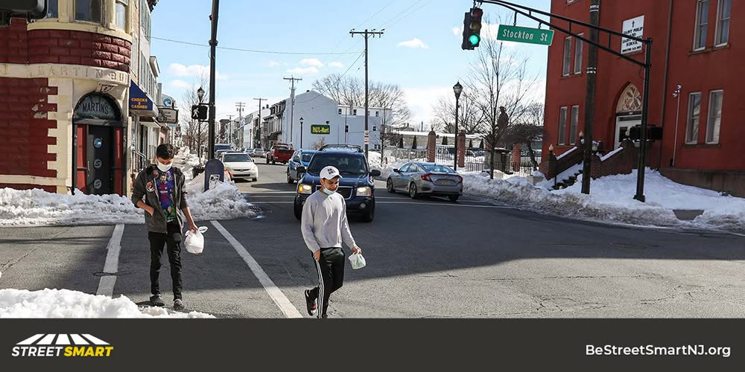 | Driver safety tip: Stop for pedestrians in marked crosswalks and yield when turning at intersections. It’s the law. #BeStreetSmartNJ
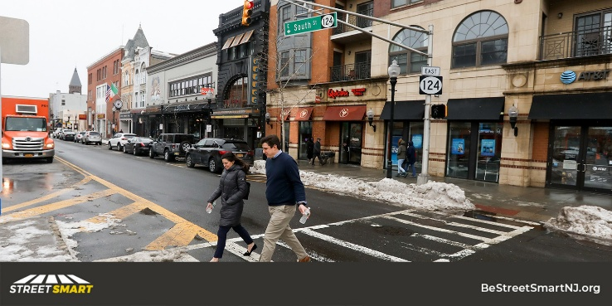 | Pedestrian safety is all of our responsibility. Play your part by stopping for pedestrians at an intersection. It’s the law. #BeStreetSmartNJ

Spring Summer/ Images
Image | Post Text
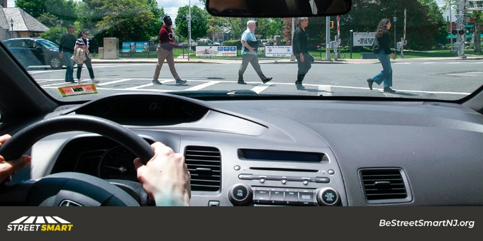 | Driver safety tip: Eliminate all distractions when driving. Your hands should be on the wheel and your focus should be on the road. #JustDrive #EndDD #HeadsUpPhonesDown #BeStreetSmartNJ
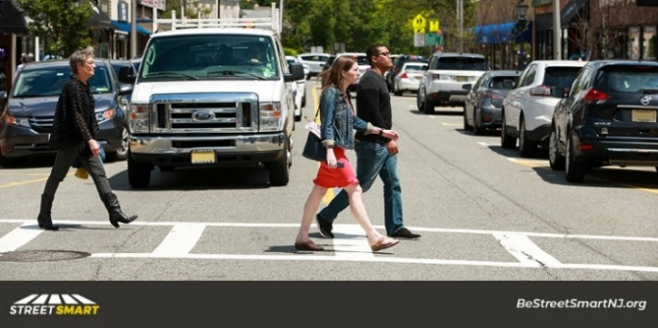 | Motorists in New Jersey MUST stop for people in marked crosswalks. Failure to do so could result in 2 points and a $200 fine. #BeStreetSmartNJ
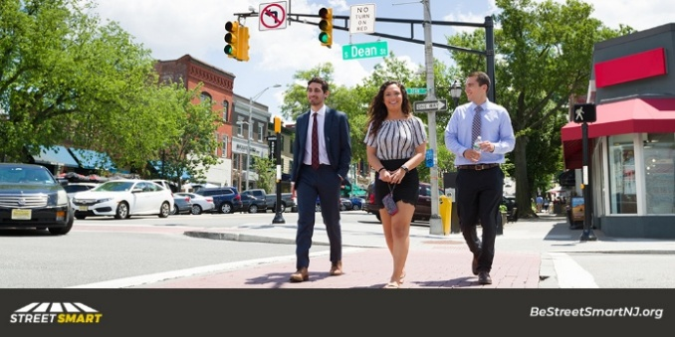 | Driver safety tip: Stop for people in marked crosswalks and yield when turning at intersections. It’s the law. #BeStreetSmartNJ
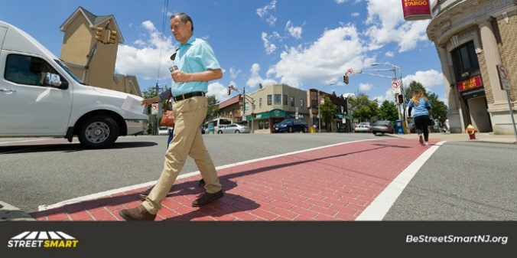 | Driver safety tip: When the light is red, a person crossing on a walk signal has the right of way. Stop and wait before turning, it’s the law. #BeStreetSmartNJ
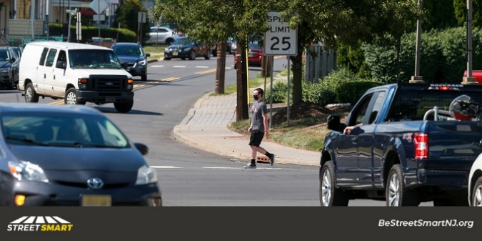 | Driver safety tip: Slow down for safety. Travelling at a lower speed WILL save a life. #BeStreetSmartNJ
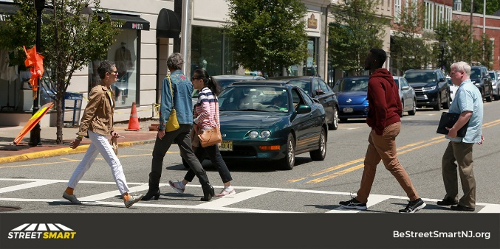 | More than half of pedestrian fatalities occur on local and county roads. Slow down for safety. #BeStreetSmartNJ
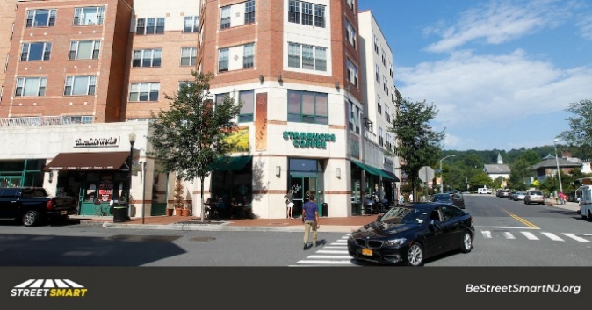 | Speeding, illegal turns and distracted driving put pedestrians at risk. We all have a responsibility to make our streets safer. #BeStreetSmartNJ
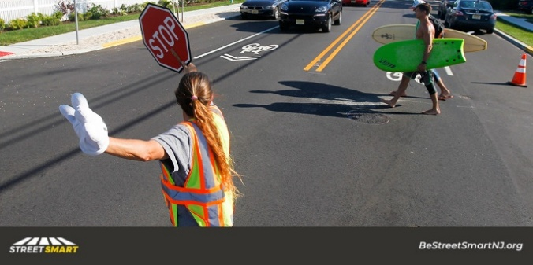 | All intersections are crosswalks. If the light is red, drivers MUST stop for pedestrians, even if the crosswalk is unmarked. Drive Smart. #BeStreetSmartNJ
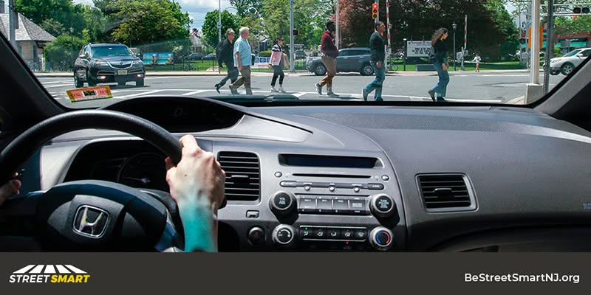 | Driver safety tip: Look and stop for pedestrians and bicyclists when turning right on red. #BeStreetSmartNJ
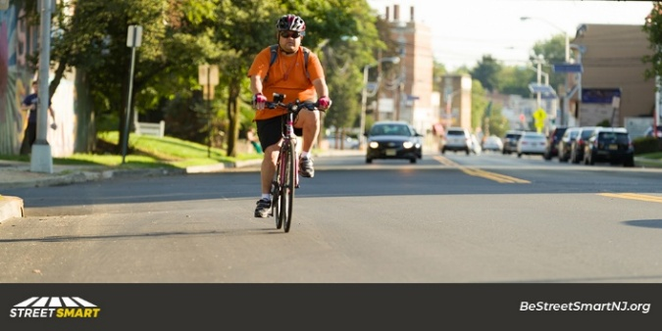 | Driver safety tip: Create a safety zone. Allow four feet when passing bicyclists or other vulnerable road users. #SafePass4NJ #PassMeLikeYouKnowMe #BeStreetSmartNJ
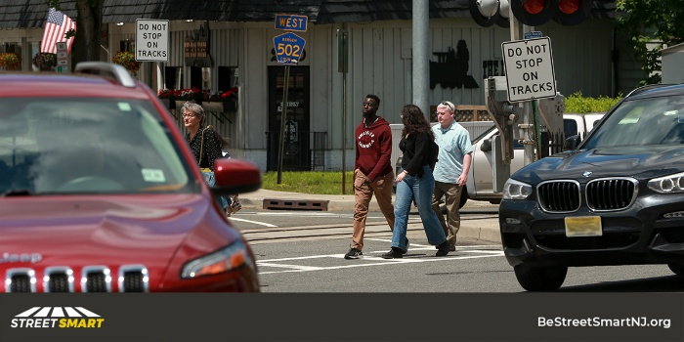 | Driver safety tip: Do not pass vehicles stopped at or adjacent to crosswalks and intersections. Look for pedestrians before proceeding. #BeStreetSmartNJ
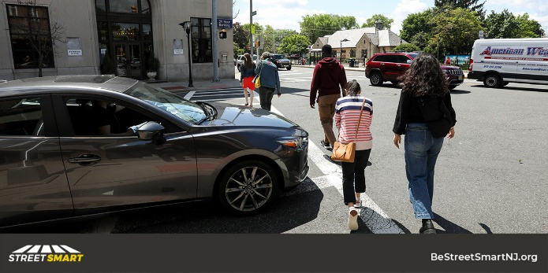 | Driver safety tip: Do not block or park in crosswalks. They’re pedestrian safety zones. #BeStreetSmartNJ
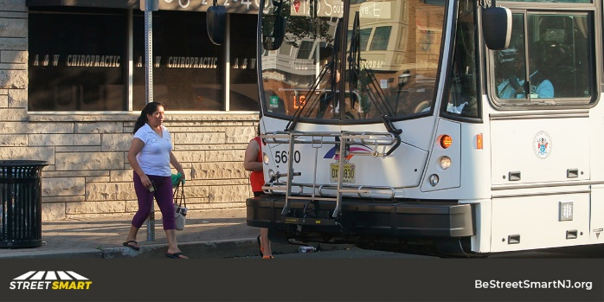 | Driver safety tip: Be extra alert around buses and look out for pedestrians. #BeStreetSmartNJ
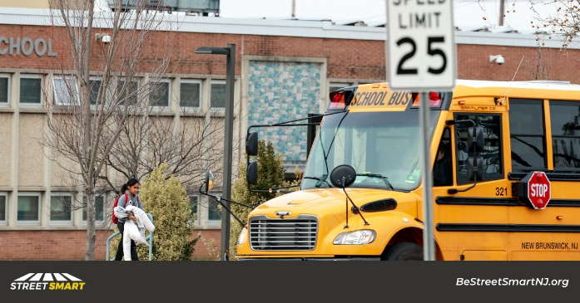 | Slow down for safety — especially around schools. If a person is struck by a car going 20 mph or slower, the odds of survival are good. Above 35 mph, the impact is likely to be fatal. #BeStreetSmartNJ
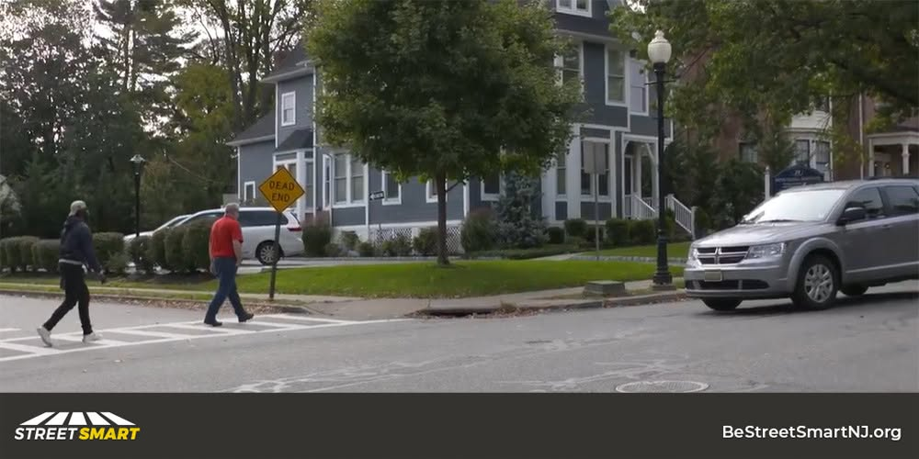 | Driver safety tip: Stop for pedestrians in marked crosswalks and yield when turning at intersections. It’s the law. #BeStreetSmartNJ
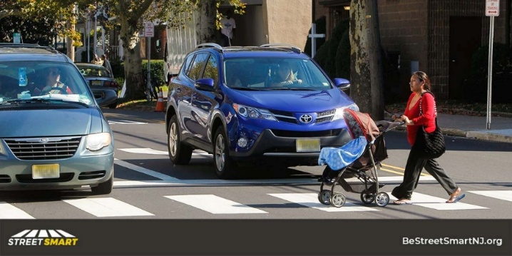 | Pedestrian safety is all of our responsibility. Play your part by stopping for pedestrians at an intersection. It’s the law. #BeStreetSmartNJ

