Street Smart NJ Sample Social Media Posts

Seasonal Messages

Summer/Jersey Shore
Photos | Post Text
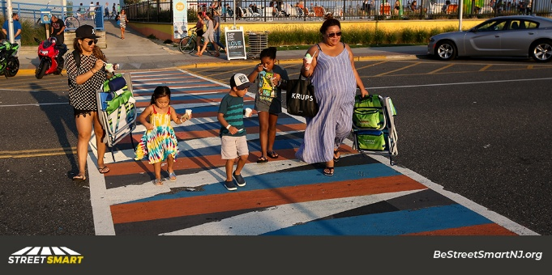 | Teach children to wait for the green light or walk signal, to use crosswalks and to look left, right and then left again before crossing. Teaching safe behavior at a young age can save a life. #BeStreetSmartNJ
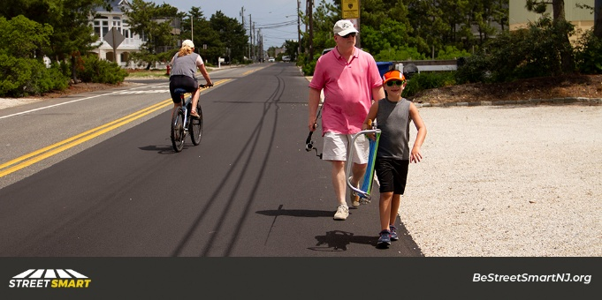 | Summer Safety Tip: Bike with the flow of traffic. If you're walking and there are no sidewalks, walk against the flow of traffic so you can see vehicles approaching. #BeStreetSmartNJ
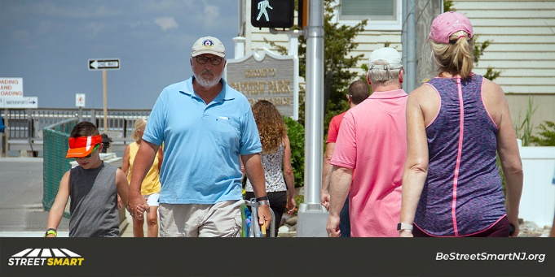 | Just like drivers, there are laws pedestrians must obey too. Crossing against the signal isn't just dangerous, it can result in a $54 fine. #BeStreetSmartNJ
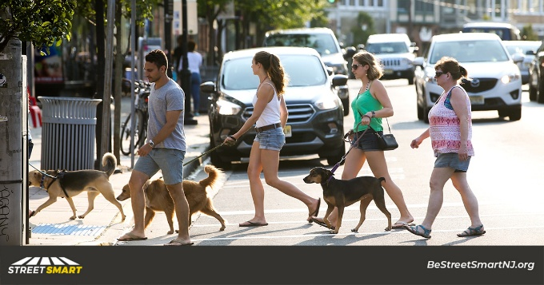 | Summer is a great time to go for a walk. Remember to use crosswalks or cross at intersections whenever possible. Drivers must stop for people in marked crosswalks — it's the law. #BeStreetSmartNJ
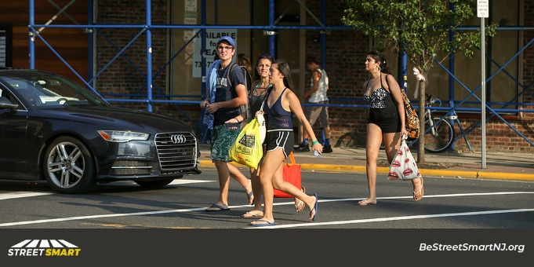 | Staying focused on the road whether you're driving or walking is critical. If your focus is on your phone, you might miss what's in front of you. Keep your eyes on the road so you arrive safely. #BeStreetSmartNJ
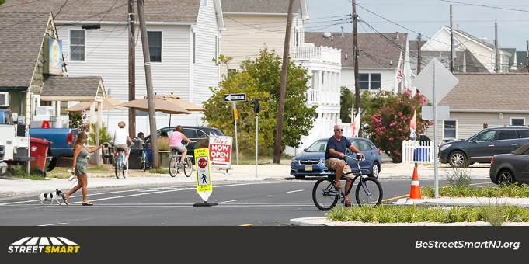 | With more people out cycling and walking it is more important than ever for drivers to #ShareTheRoad, avoid distractions and slow down for safety. #SafeDriversSaveLives #BeStreetSmartNJ
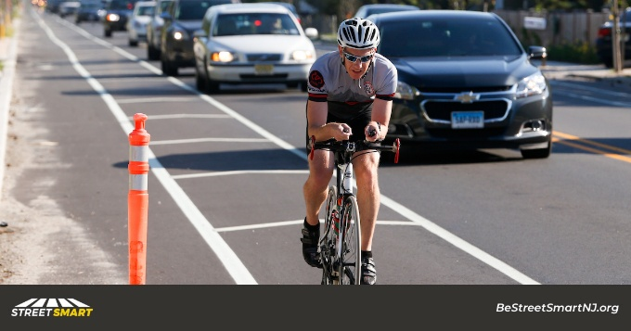 | Cyclists should always bike with the flow of traffic. Drivers: share the road and move over or slow down when passing a cyclist — it’s the law. #SafePass4NJ #BeStreetSmartNJ
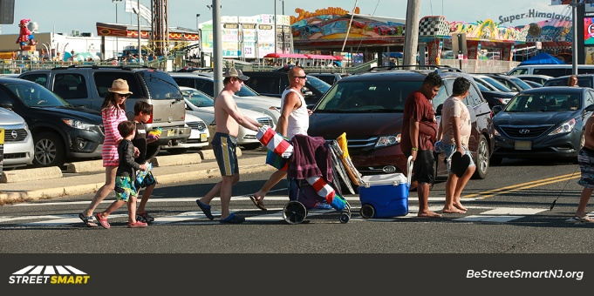 | Motorists in NJ must stop for pedestrians in marked crosswalks. Failure to observe them may subject motorists to one or more of the following:  * 2 points  * $200 fine plus court costs  * 15 days community service  * Insurance surcharges
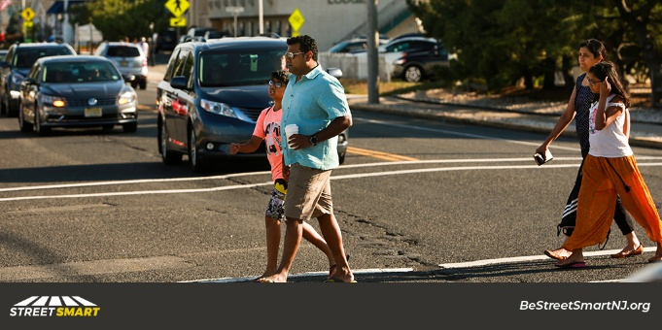 | Pedestrian Safety Tip: Use crosswalks. When there are no marked crosswalks, cross at intersections from corner to corner. #BeStreetSmartNJ
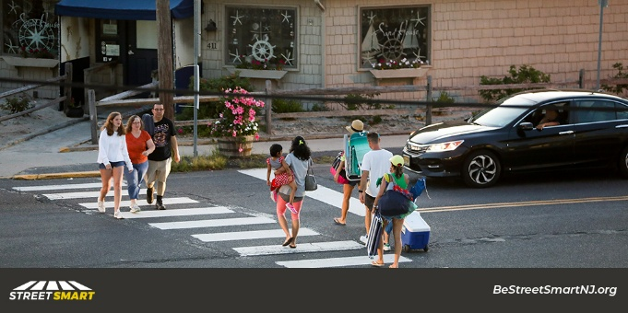 | Drivers must stop for people in marked crosswalks and yield when turning at intersections — it’s the law. Failing to do so won't just result in a ticket, it could cause a serious or fatal crash. #BeStreetSmartNJ
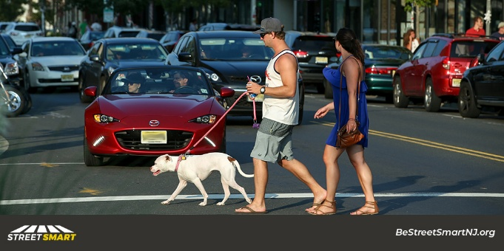 | New Jersey’s pedestrian fatality rate is nearly double the national average. Stopping for people crossing, avoiding distractions and obeying speed limits will save lives. #JustDrive #SafeDriversSaveLives #BeStreetSmartNJ
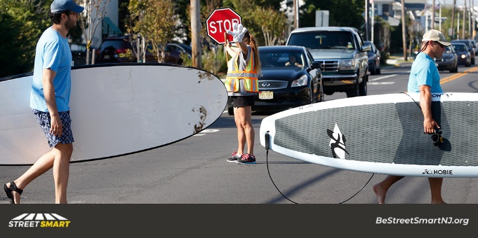 | We all have a role to play in making our streets safer. Drivers must stop for people crossing, slow down and avoid distractions. When you’re walking, use crosswalks or cross at intersections. Drive Smart. Walk Smart. #BeStreetSmartNJ
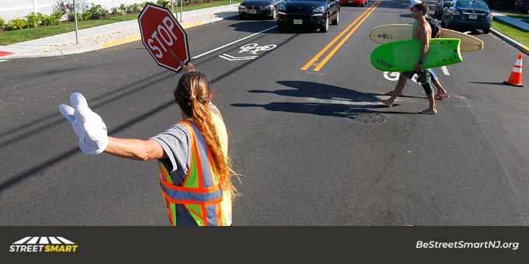 | Did you know that every intersection has a crosswalk, even if it's not marked? Drivers must stop for people in marked crosswalks and at intersections — it's the law in NJ. #BeStreetSmartNJ
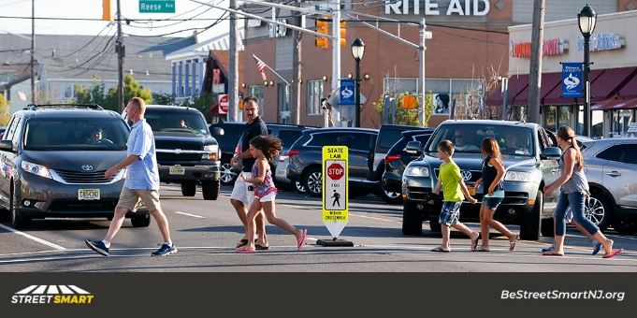 | Stopping for people in crosswalks won't just help you avoid a ticket, it will make our roads safer and save lives. #SafeDriversSaveLives #BeStreetSmartNJ
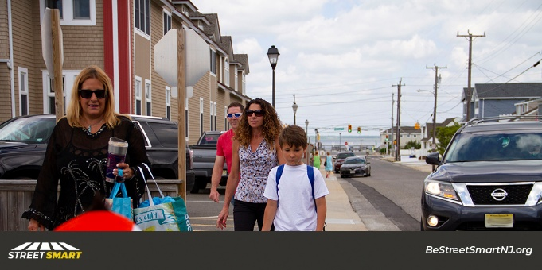 | Stopping and looking for people crossing before turning will help you avoid crashes and save lives. #SafeDriversSaveLives #BeStreetSmartNJ
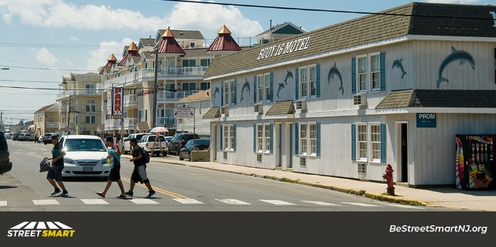 | Crosswalks are pedestrian safety zones. By law drivers must stop for people crossing in them. #SafeDriversSaveLives #BeStreetSmartNJ
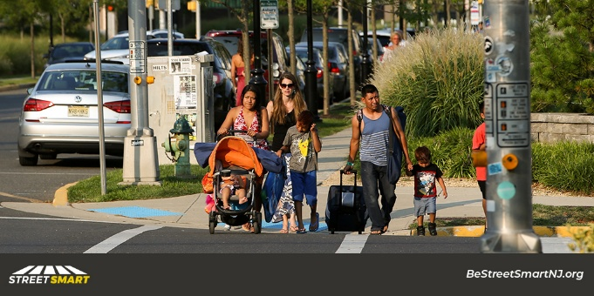 | Nearly half of all fatal crashes happen on county and local roads — not highways. Slowing down and looking for people crossing will save lives. #SafeDriversSaveLives #BeStreetSmartNJ
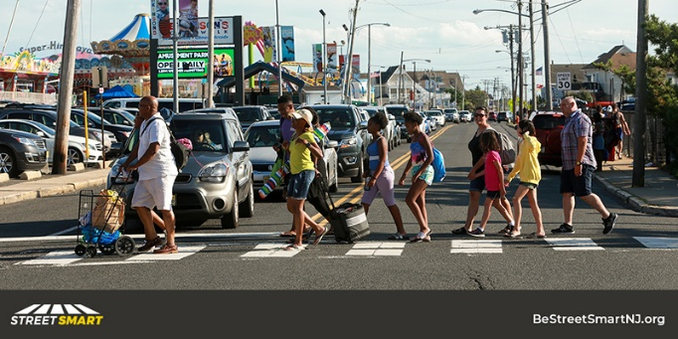 | Cross in marked crosswalks or at intersections when possible. Drivers must stop for people in crosswalks — it's the law. #BeStreetSmartNJ  _____________________________________  Always stop for pedestrians in the crosswalk or where pedestrian crosswalk signs are posted. #BeStreetSmartNJ
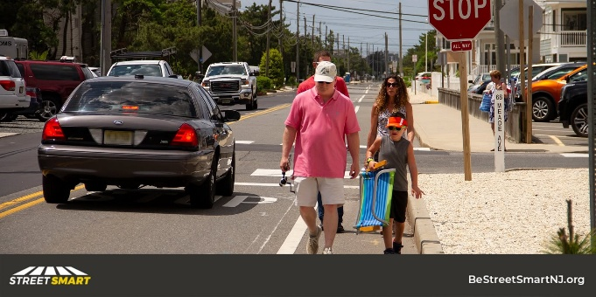 | DYK that NJ has a safe passing law? Drivers must move over if possible, provide at least 4 feet or slow down when passing people walking or biking. #SafePass4NJ #SafeDriversSaveLives #MoveOver #BeStreetSmartNJ

Back to School
Photos | Post Text
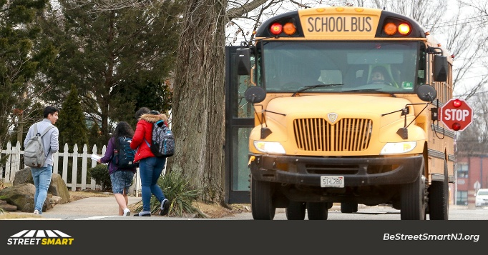 | The greatest risk to a child isn’t riding a school bus but approaching or leaving one so it's especially important to pay attention. #BeStreetSmartNJ
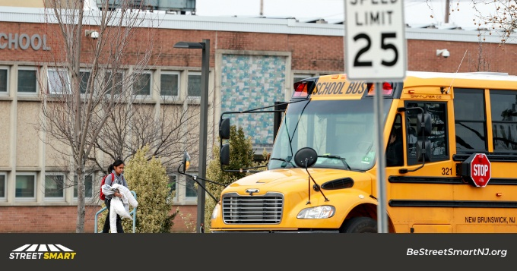 | Slow down for safety — especially in school zones, which have lower speed limits — and be extra alert for children walking and biking to and from school. #SafeDriversSaveLives #BeStreetSmartNJ
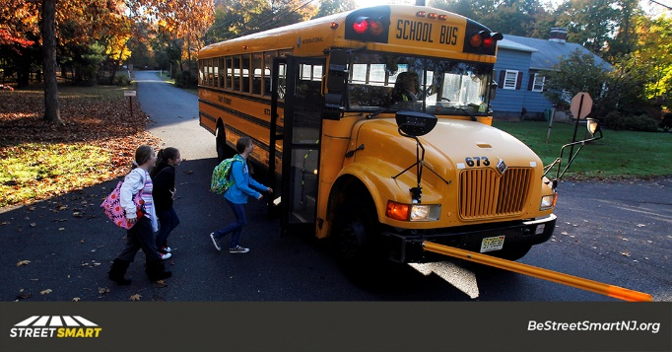 | Drivers should always stop for school buses with their lights on and stop signs extended — it's the law. In #NewJersey, drivers are also legally required to stop for people in crosswalks & crossing at intersections. #BeStreetSmartNJ
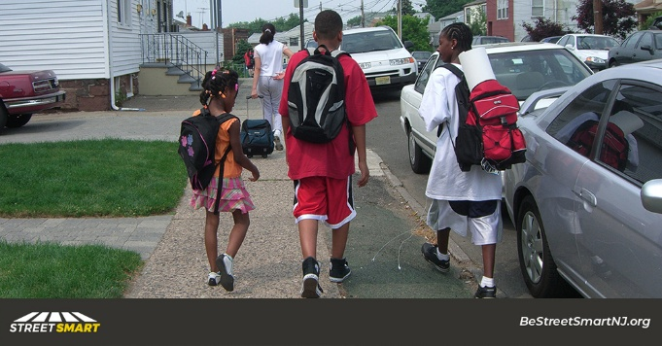 | Children head back to school this month. Help make our streets safer for them by slowing down, avoiding distractions and stopping at crosswalks. #BackToSchool #BeStreetSmartNJ
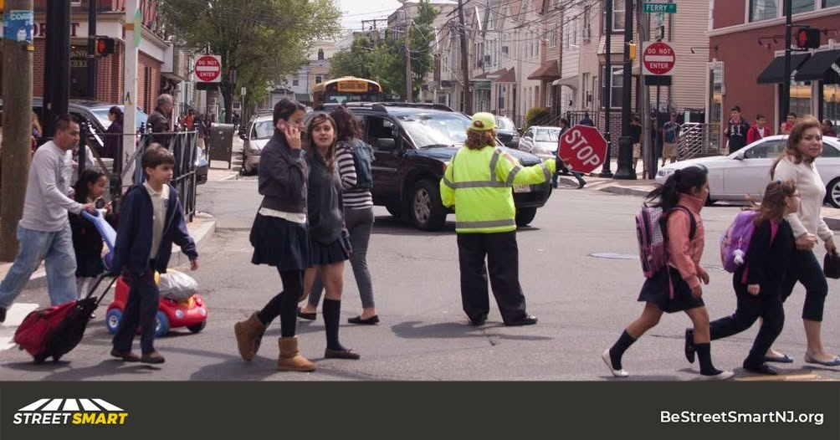 | Always stop for people crossing in crosswalks, at intersections and when the crossing guard has a stop sign raised. Doing so will help make our streets safer for everyone. #BeStreetSmartNJ
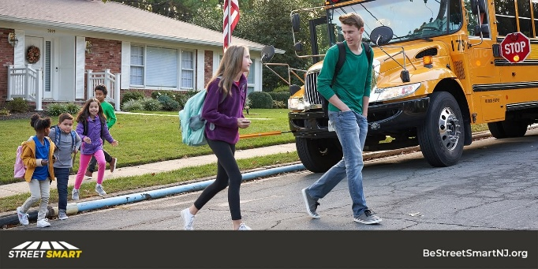 | If your focus is on your phone or the radio, you might not see who is right in front of you. Driver inattention is the leading cause of fatal crashes in NJ. Saving a life is as simple as focusing on the road when driving. #JustDrive #EndDD #ItCanWait #BeStreetSmartNJ
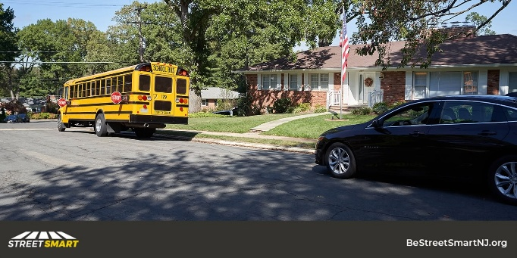 | Drivers are legally required to stop for school buses with extended stop signs and flashing lights. Remember to leave plenty of room for students to cross and safety enter and exit the bus. #BackToSchool #BeStreetSmartNJ
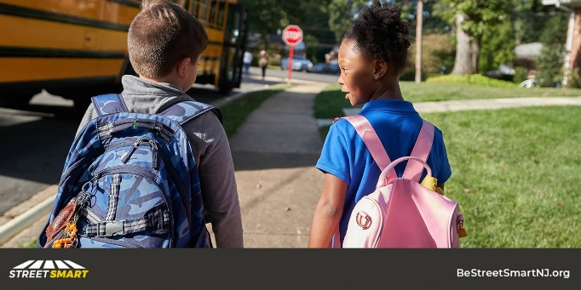 | The school bus is one of the safest modes of #transportation but illegal passing is a deadly risk. Drivers should always come to a complete stop when a stop-arm is extended and the red lights are flashing #BeStreetSmartNJ
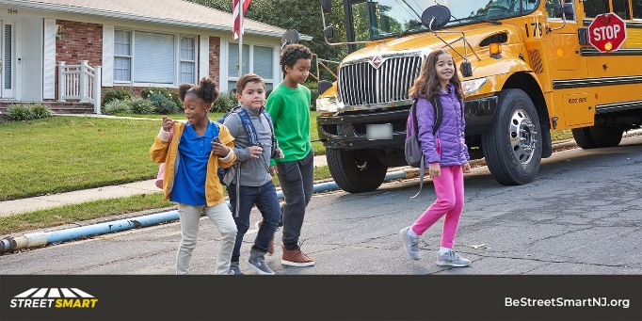 | It's back-to-school season! It’s likely you or your child will be a pedestrian at some point in the school day. Here are tips for keeping kid safe walking or bicycling to school via NHTSA: https://www.nhtsa.gov/school-bus-safety/keeping-children-safe

Halloween
Photos | Post Text
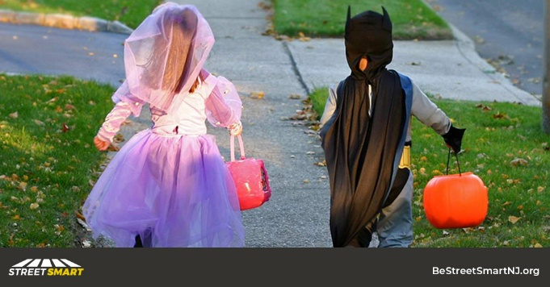 | Halloween is one of the deadliest days for young pedestrians, but it doesn't have to be. Avoiding distractions, slowing down and stopping and looking for people crossing will make streets safer and save lives. #BeStreetSmartNJ
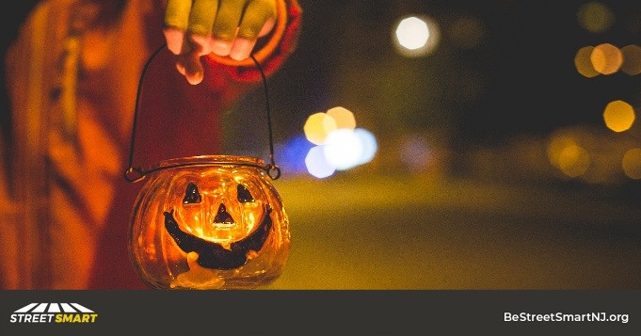 | Happy #Halloween! You can keep children safe today by avoiding distractions while driving, slowing down, and watching and stopping for people crossing. #BeStreetSmartNJ
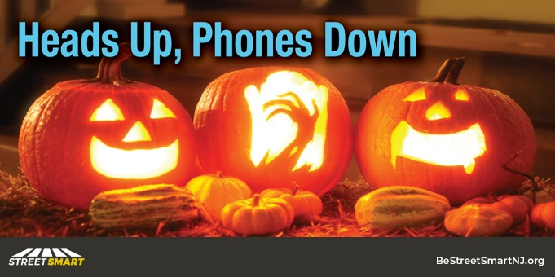 | Driver inattention is the leading cause of crashes in NJ. Help make Halloween safer for everyone this year by avoiding distractions. #HeadsUpPhonesDown #EndDD #SafeDriversSaveLives
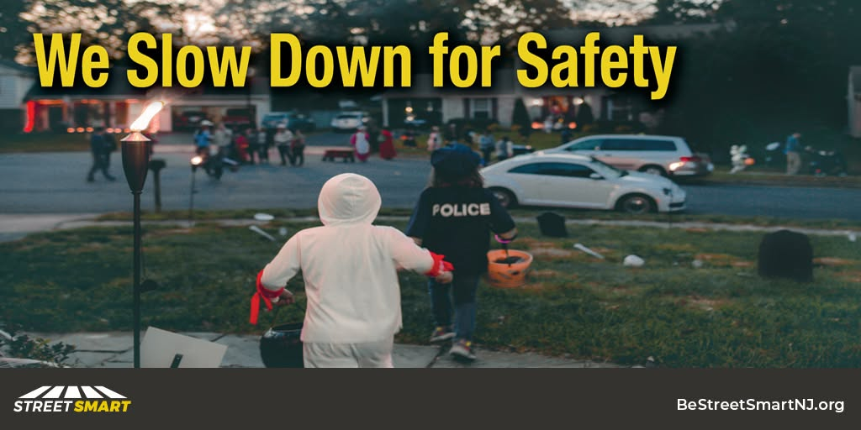 | Help make NJ streets safer for trick-or-treaters by avoiding distractions, driving slow and stopping for people crossing. #BeStreetSmartNJ
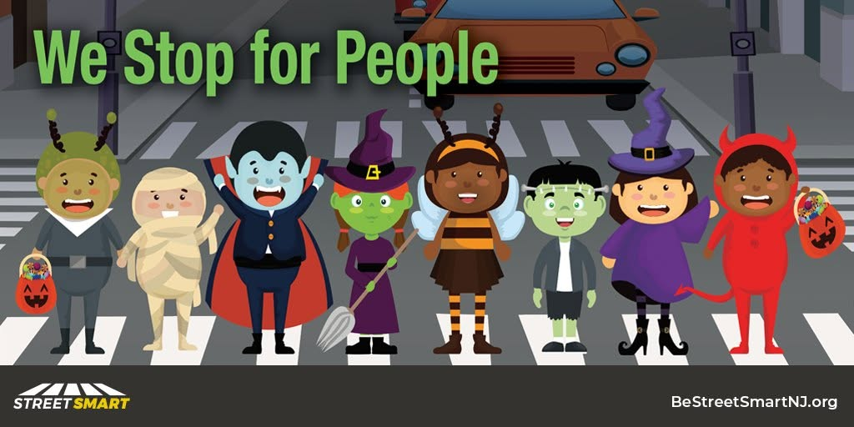 | In NJ every intersection has a crosswalk even if it's not marked. Drivers must stop for people crossing in crosswalks. Be extra cautious on #Halloween and look and stop for trick-or-treaters. #BeStreetSmartNJ

